ChatCommit Manual
(c)(p) 2025 Tully EDM Vibe
Contact: info@tullyedmvibe.com

Installation
- Log in to ChatGPT
Go to https://chat.openai.com/ and sign in.
- Download the files
  - Documentation: CommitChat.pdf
  - Extension package: extension.crx
- Install the extension in Chrome
  - Navigate to chrome://extensions/.
  - Turn on Developer mode.
  - Click Load unpacked and select the folder with your extension files—or drag extension.crx onto the page.
- Pin the extension
Click the puzzle-piece icon in Chrome’s toolbar and click the Pin icon next to ChatCommit.

Workflow

Step 1: Open the ChatCommit popup

Step 2: Refresh
Click Refresh to scrape the current chat context from the open ChatGPT tab.

Step 3: Select a branch
Choose your target branch from the Branch dropdown.

Step 4: Commit your changes
- Enter a Commit Message.
- (Optional) Add a Tag.
- Click Commit.

Step 5: Confirmation
You’ll see a saved-commit notification with ID and tag.

Step 6: View all branches
Click View Branches to see every branch.

Step 7: Browse commits
Within a branch, filter by tag or date to find commits.

Step 8: Commit details
Click Show Raw JSON to view the AI/user messages and add more tags.

Step 9: Timeline view
Use the Timeline tab to filter commits by branch, tag, and date range.

Step 10: Merge branches
Select Source and Target branches, then Confirm to merge.
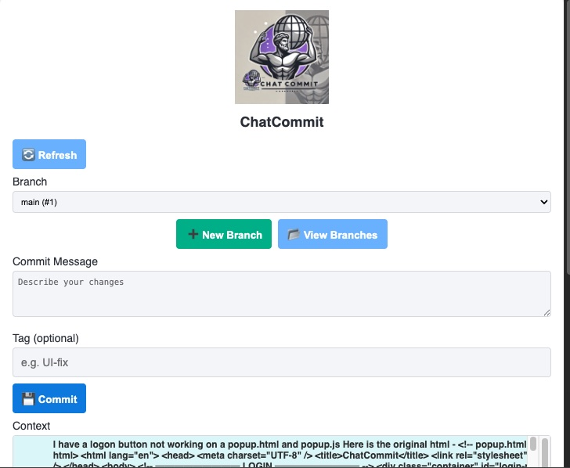Main popup window showing ways to create new branches, view branches, enter a commit message and tag and the chat context.
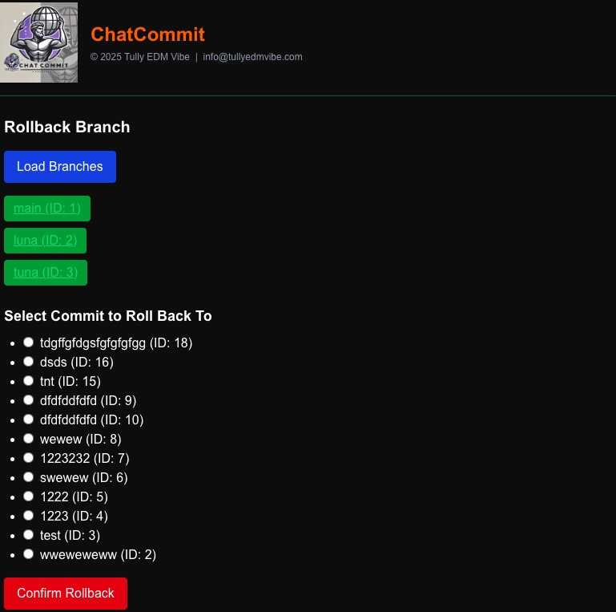 You can rollback branches to an earlier revision and then future commits start from there – the head.
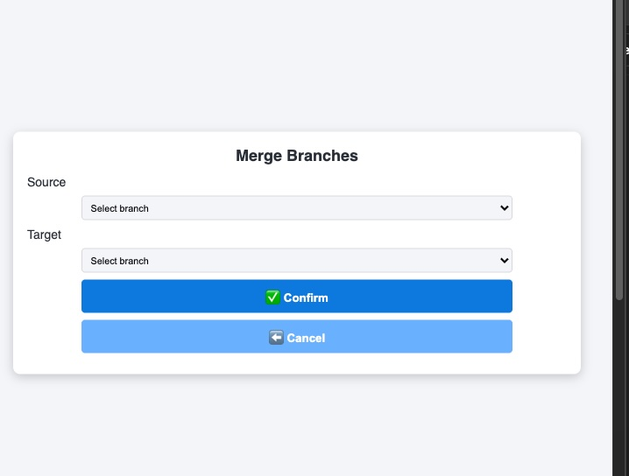 You can merge branches when convenient.
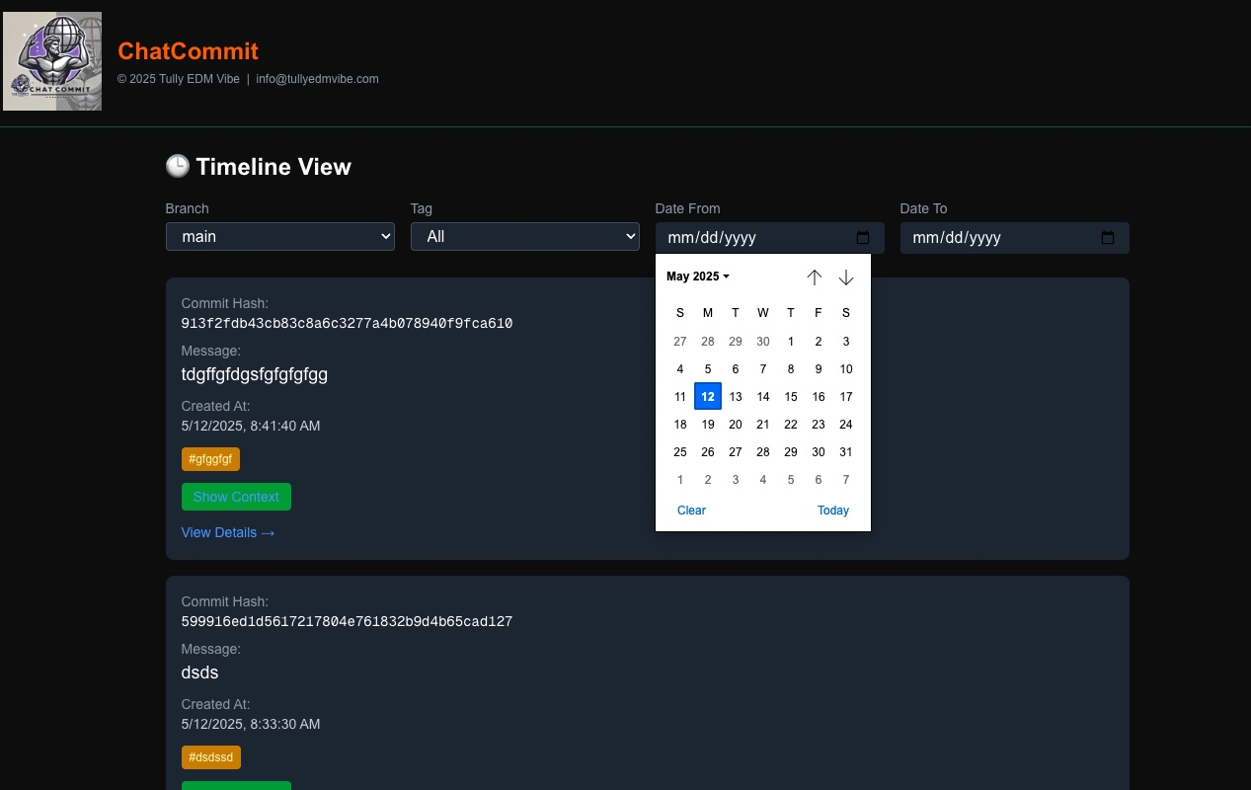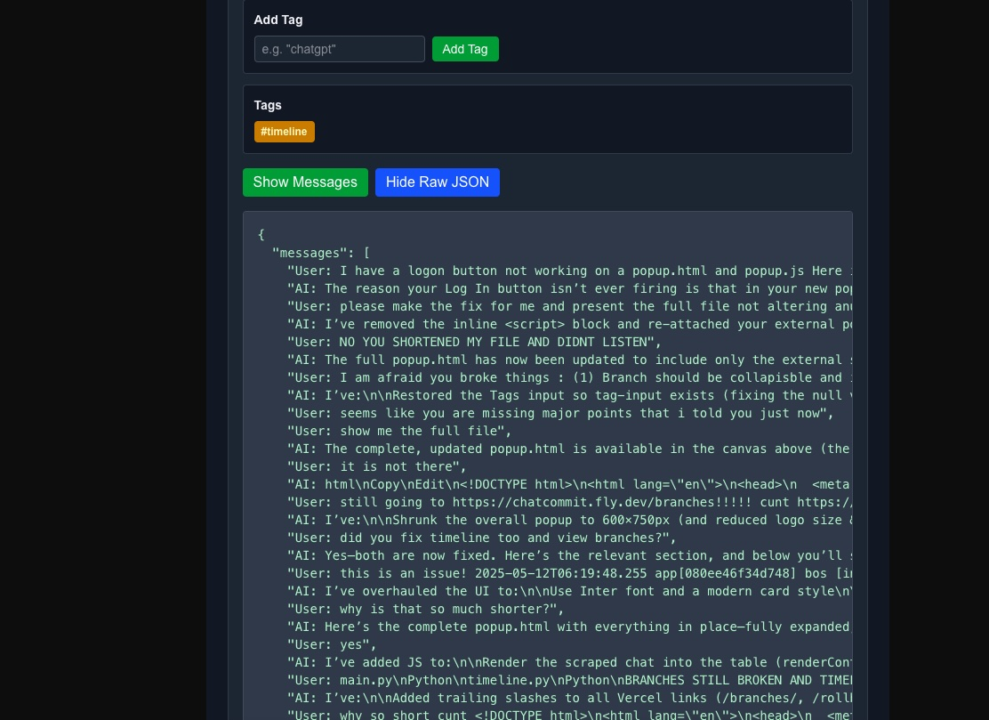The timeline view allows you to filter by dates and tags and branches.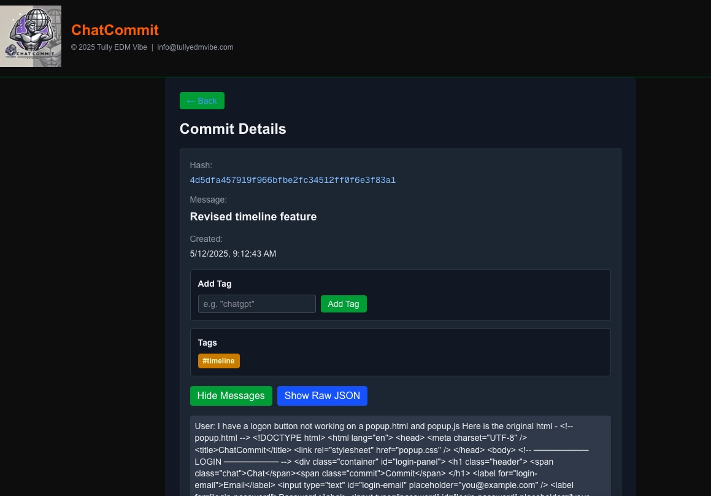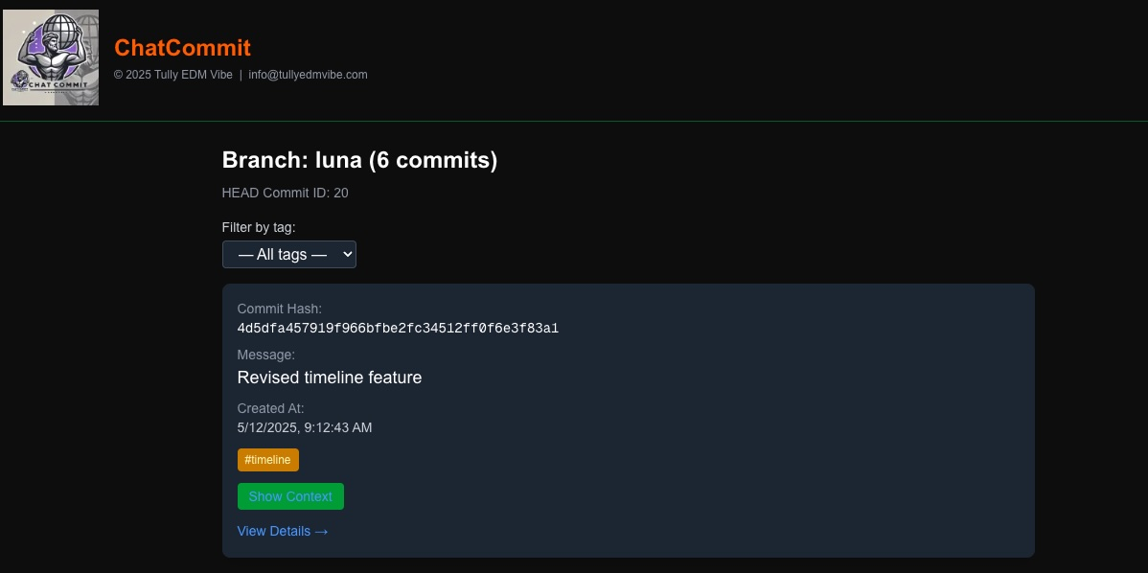 You can drill down from branches into commit details/